LoginScenario_TestForMarineValidLogin_Instance1_03-Jul-2017_06-30-49_AM_Enter_user_credentials.png

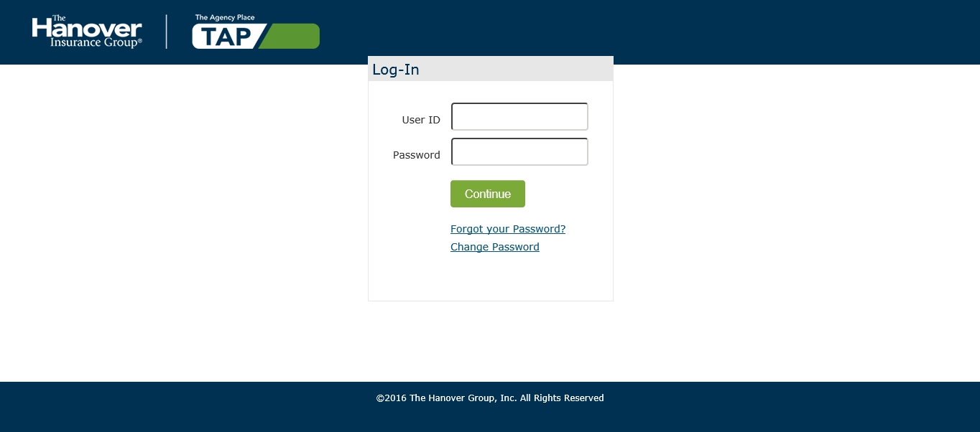

LoginScenario_TestForMarineValidLogin_Instance1_03-Jul-2017_06-30-50_AM_Login.png

